Research to investigate the positive correlation between Negative Affectivity and Social Inhibition

Content:

Abstract. 3
Review of Literature 5
Methodology 7
Results 9
Discussion 14
Ethical issues 17
References 18
Bibliography 19
Appendices 20

Acknowledgement:
Three members of the research group were working together.
Thank you to all participants.

Abstract

Denollet (2005, cited in Eysenck, 2009, p. 93) found that individuals with Type D personality are prone to stress. Type D personality type is characterized by high Social Inhibition and high Negative Affectivity.. The Type D Scale (DS14) was developed by Denollet to measure Negative Affectivity and Social Inhibition. DS14 has 14 items. Seven Negative Affectivity items cover feelings of dysphoria, worries and irritability. Seven Social Inhibition items cover discomfort in social interactions, reticence and social poise. Items are answered on a 5-point Likert type scale (0 = false, 4 = true). Total amount of Negative Affectivity and Social Inhibition scores range from 0 to 28. If both Negative Affectivity and Social Inhibition scores are above 10 Type D is classified (2005, cited in Bergvik et al, 2010, p.334-340).

The design of the investigation was correlation. The method of the research was questionnaire. Co-variables of the correlation were tested. Co-variables of the correlation were Negative Affectivity and Social Inhibition. 30 adult participants were tested. Opportunity sampling was used.
Introductions were read to participants (Appendix 1). They were given the Questionnaire (Appendix 2). Brief and instruction was read (Appendix 3). Participants Data response sheets were collected (Appendix 4). Debrief was read (Appendix 5).Participants’ scores were counted (Appendix 6) and all data was arranged (Appendix 7). Inferential Analysis (Appendix 8) and Descriptive Statistics (Appendix 9) were calculated.

Alternative hypothesis:
There will be a positive correlation between Social Inhibition scores and Negative Affectivity scores.

Null hypothesis:
There will be no positive correlation between Social Inhibition scores and Negative Affectivity scores.

Results show a positive correlation between Social Inhibition scores and Negative Affectivity scores.
Spearman inferential statistics was used because the design of the investigation was correlation and ordinal level of data was measured.
Inferential statistics: when N=30, the observed value rs=+0.556 and the critical value equals 0.467, the result is significant at the 0.5% level for one-tailed test (p<0.005).
The alternative hypothesis is supported. The null hypothesis can be rejected.

Review of Literature
Generally the presence of audience can make someone’s performance improve (Social Facilitation) or decline (Social Inhibition). The outcome depends on the person and on the task the person is doing. When a person believes that his/her behaviour might cause the audience's disapproval it can negatively affect his/her performance; Social Inhibition negatively affects performance. In a study pool players were watched at the university union to survey Social Facilitation/Inhibition. Good players increased performance when a group of four people began watching them. Average pool players’ performance decreased when four people started watching them (Micheals et al, 1982, cited in Brewer, 2009 p.13).
Watson and Tellegen (1985, cited in Eysenck, 2009, p. 79) and Watson and Clark (1992, cited in Eysenck 2009, p. 79) made a hierarchical model that consisted of two independent factors (at the upper level) called Negative Affect and Positive Affect. There were several correlated emotional or mood states (at the lower level), which could be related to the structure formed by Negative Affect and Positive Affect. Russel proposed another two-dimensional model that was similar to the model made by Watson and Tellegen (1985) but it had two other independent dimensions: pleasure-misery and arousal-sleep. Detailed analyses of emotion questionnaires showed that these two models were alternative descriptions of the same thing (Russel& Barrett, 1999, cited in Eysenck, 2009, p. 79).
For over a decade data have indicated that Negative Affectivity broadly correlates with both anxiety and depression whereas diminished Positive Affectivity only related to depression (Burns and Eidelson, 1998, cited in Kashdan, 2008, p. 1). However, a more recent work suggested that diminished Positive Affectivity was also consistent with social anxiety (Kashdan, 2007, cited in Kashdan, 2008, p. 1).

Clark, Watson, and Mineka defined negative affect as a temperamental sensitivity to negative stimuli resulting in fear, anxiety, depression, guilt and self-dissatisfaction; individuals with high Negative Affectivity were likely to experience negative emotions more frequently than people with lower Negative Affectivity. Peoples with high Negative Affectivity reported being much more stressed and distressed than those low in Negative Affectivity. Negative Affectivity seemed to cause both anxiety and mood disorders. It has been suggested that the sharing of this common factor may explain the similarity between mood disorders and anxiety disorders (1994, cited in Norton, 2011, pp. 2-3).

Denollet found that individuals with Type D personality were prone to stress. Type D personality type is characterized by high social inhibition and high Negative Affectivity. (2005, cited in Eysenck, 2009, p. 93). The Type D Scale (DS14) was developed by Denollet to measure Negative Affectivity and Social Inhibition. DS14 has 14 items. Seven Negative Affectivity items cover feelings of dysphoria, worries and irritability. Seven social inhibition items cover discomfort in social interactions, reticence and social poise. Items were answered on a 5-point Likerttype scale (0 = false, 4 = true). The total amount of Negative Affectivity and Social Inhibition scores range from 0 to 28. If both Negative Affectivity and Social Inhibition scores were above 10, Type D was classified (2005, cited in Bergvik et al, 2010, p.334-340).

Methodology
The design of the investigation was correlation. The method of the research was questionnaire. Co-variables of the correlation were tested. Co-variables of the correlation were Negative Affectivity and Social Inhibition. It was a one-trail questionnaire.
Opportunity sampling was used. 30 adult participants were tested. It included seventeen females and thirteen males. Sixteen participants had age range 18-25, seven participants had age range 26-33, three participants had age range 34-41, two participants had age range 42-49 and two participants had age range 50 and over. Details about participants can be found in Raw data collection (see Appendix 7).
All participants were tested in Norwich in a relaxed environment, but in different places. Two participants were tested at Norfolk House library – learning environment, five participants were tested in St. Andrew’s house – learning environment, five at home environment, eight participants were tested at their work – working environment and ten participants were tested at University of East Anglia – learning environment.
Materials used for this research were Introduction (Appendix 1), Questionnaire – stimuli material (Appendix 2), Brief and Instruction (Appendix 3) and Debrief (Appendix 5).
Procedure:
Participants were approached in a relaxed home environment, in a work environment or in a school environment. Participants were asked if they were willing to participate in this project and the researcher read the Introduction (Appendix 1). All participants agreed to participate in this project. Questionnaires – stimuli material (Appendix 2) were provided for participants to tick the consent box and the appropriate box in the gender section and in the age range section. The investigation was briefly explained and instructions were given (Appendix 3). Participants filled in the questionnaire and Data response sheets were collected (Appendix 4). The Debrief was read to participants and they had an opportunity to get researchers’ email address. Also they had a chance to ask questions (Appendix 5). Later participants’ scores were calculated using the Mark sheet (Appendix 6). Scores from the Mark sheet, participants’ gender and their age ranges were written down on the Raw data collection sheet (Appendix 7). Inferential Analysis (Spearman rho was calculated – Appendix 8a and Appendix 8b) and Descriptive Statistics (Appendix 9a and Appendix 9b) were calculated.

Results
Descriptive Statistics:
Table 1
Summary table of Measures of centre tendency and dispersion
Median of Social Inhibition Scores | Median of Negative Affectivity Scores | Range of Social Inhibition Scores | Range of Negative Affectivity Scores
10.5 | 13 | 24 | 24

The summary table does not show a big difference between the Median of Social Inhibition Scores and the Median of Negative Affectivity Scores. The Range of Social Inhibition Scores and the Range of Negative Affectivity Scores are equal.
Results support the alternative hypothesis.
For calculation see Descriptive Statistics Calculation (Appendix 9a).

Figure 1
Scattergram of Scores of Negative Affectivity and Scores of Social Inhibition
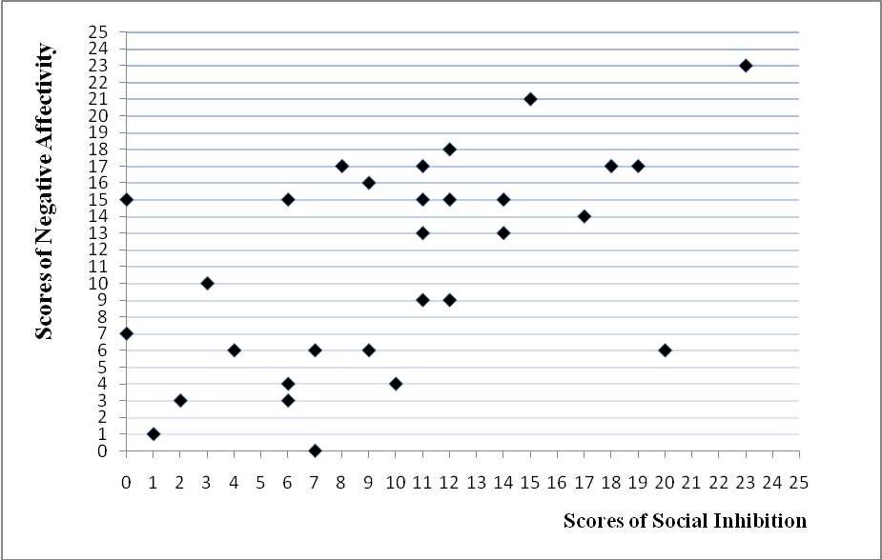
This scattergram shows trend from bottom left to top right, which indicates a positive correlation of Social Inhibition scores and Negative Affectivity scores.
Figure 1 supports the Alternative hypothesis. However, few points are deviant. For example, Participant 10 had a Negative Affectivity score 20 and a Social Inhibition score 6.

Scores from Appendix 7 are used to draw this scattergram.

Figure 2
Male-female percentage of participants
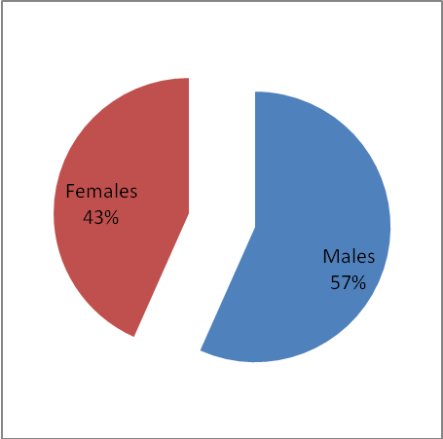
Figure 2 is a pie chart showing that 57% of participants were male and 43% of participants were female – gender is not equally represented.
For calculation see Descriptive Statistics Calculation (Appendix 9b).

Figure 3
Percentages of participants by Age ranges
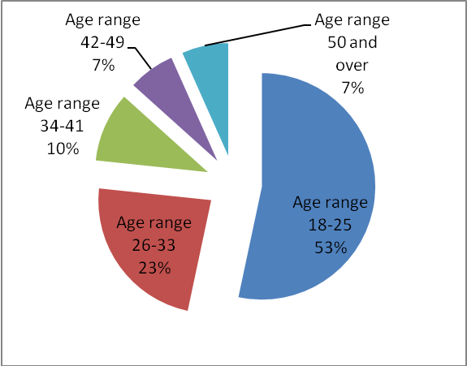
Figure 2 is a pie chart showing percentages of participants by Age ranges. Age ranges are not equally represented.
For calculation see Descriptive Statistics Calculation (Appendix 9b).

Inferential statistics:
Statistical conclusion
When N=30, the observed value rs=+0.556 and the critical value equals 0.467, the result is significant at the 0.5% level for one-tailed test (p<0.005). Therefore the null hypothesis can be rejected.
See Appendix 8 for calculations.

Discussion
Micheals et al (1982, cited in Brewer, 2009 p.13) found that audience can make someone’s performance decline if the person has Social Inhibition. Nevertheless, the performance depends on the task as well.
In this research certain participants had high scores in the Social Inhibition questionnaire. These scores can show an indication for Social Inhibition, but it cannot be related to individual performances, because other factors were not known. So the research made by Micheals et al cannot be supported by this research.

According to Watson and Clark (1992, cited in Eysenck 2009, p. 79) there are several emotional or mood states which can be related to negative affectivity.
In this research a questionnaire was used to examine negative affectivity. Questions had been designed to measure emotional or mood states associated to negative affectivity. Therefore it can be concluded that the Watson and Clark theory is supported by this research.

Burns and Eidelson found that Negative Affectivity broadly correlates with both anxiety and depression (1998, cited in Kashdan, 2008, p. 1).
In this research a questionnaire was used to measure moods and emotions. In relation to Burns’ and Eidelson’s study, there was a relationship between participants’ scores of the Negative Affectivity test and the level of anxiety and depression reported by participants.
Clark, Watson, and Mineka (1994, cited in Norton, 2011, pp. 2-3) defined Negative Affectivity as a temperamental sensitivity to negative stimuli resulting in fear, anxiety, depression, guilt and self-dissatisfaction. People with high Negative Affectivity report being much more stressed and distressed than those low in negative affectivity.
In relation to this study, individuals with high scores in Negative Affectivity test may indicate sensitivity to negative stimuli. They will likely report being much more stressed and distressed than people with low scores in negative affectivity.

Denollet (2005, cited in Eysenck, 2009, p. 93) found that individuals with Type D personality were prone to stress. Type D personality type is characterized by high Social Inhibition and high negative affectivity.
In this investigation Denolett’s DS14 personality test was used to measure Negative Affectivity and Social Inhibition. In this research many individuals had ten or higher scores both in Social Inhibition and negative affectivity. According to Denollet this is an indication for Type D personality.

In this investigation alternative hypothesis was supported and null hypothesis was rejected.

The small sample size might had an effect on results as well as it was not representative of any group or population. A bigger sample size is recommended as an amendment.
This research was carried out in different environments and at different times. These conditions might have had an effect on results and it questions the reliability of this research. If the investigation was repeated, it could be improved by doing the research for all participants at the same time and in the same environment.
Three different researchers carried out the research. If the same researcher did the research for all participants that would be an improvement.

Ethical issues
This research was carried out in accordance with BPS ethical guidelines. In the introduction researcher was introduced. Participants were addressed to confirm they were over eighteen and their consent was given to participate in this research. During the Brief and Instructions the research was shortly explained and participants were informed about their anonymity and confidentiality of the information given. They were told they were entitled to withdraw from this investigation at any time. Later during Debrief once again they were reminded about anonymity and confidentiality. To protect participants well being, the ‘test’ word was not used. Also for the same reason they were familiarised with the idea that it is not unusual to achieve different range of scores. Would they require any further help or advice, they were advised to contact the Wellbeing Zone at City College. Also they had a last chance to withdraw their results and data.
Participants did not show any signs of anxiety during research, however, some student participants did not pay full attention to the questionnaire and they showed signs of boredom.
Next time materials used for this research (Appendix 1, 2, 3 and 5) might be shorter and simpler in order to be understood better and to avoid boredom.
The researcher’s e-mail address was offered to participants in case they asked for overall results. It was explained, no individual results will be available. None of the participants asked for overall results.
Particip
ants’ anonymity and confidentiality has been protected.

Bibliography

Bergvik, S., Sorlie, T., Wynn, R. and Sexton, H. (2010) ‘Psychometric properties of the Type D scale (DS14) in Norwegian cardiac patients’, Scandinavian Journal of Psychology, 51(4), p. 334–340. [Online]. Available at: http://munin.uit.no/bitstream/handle/10037/2104/paper_2.pdf?sequence=4
Brewer, K. (2009)’Social Facilitation and Inhibition in Humans ans Animals’ Semi-academic journal for psychology students at all level, 11(1), p. 13. [Online]. Available at: https://ia600506.us.archive.org/12/items/PsychologyInformationForStudentsNo.11/psychology_information_for_students_no11.pdf(Accessed: 02/11/2013).
Burns, D. D., & Eidelson, R. J. (1998). Why are depression and anxiety correlated? A test of the tripartite model. Journal of Consulting and Clinical Psychology, 66, 461–473.
Clark, L. A., Watson, D., &Mineka, S. (1994). Temperament, personality, and the mood and anxiety disorders. Journal of Abnormal Psychology, 103, 103-116.
Denollet, J. (2005). DS14: Standard assessment of negative affectivity, social inhibition, and Type D personality. Psychosomatic Medicine, 67, 89-97.
Eysenck, M. W. (2009) Fundamentals of Psychology. New York: Psychology Press, pp. 78-79, 93-94.
Kashdan, T. B. (2007). Social anxiety spectrum and diminished positive experiences: Theoretical synthesis and meta-analysis. Clinical Psychology Review, 27, 348–365.
Micheals, J. W., Blommel, J. M., Brocato, R. M., Linkous, R. A., & Rowe, J. S. (1982). Social facilitation and inhibition in a natural setting. Replications in Social Psychology, 2, 21-24.
Norton, P. J. (2011) ’Risk Factors in the Development of Anxiety Disorders: Negative Affectivity’ Invited manuscript for Strides, pp. 2-3 [Online]. Available at: http://www.anxietybc.ca/sites/default/files/Negative%20Affectivity.pdf(Accessed: 02/11/2013).
Russel, J.A. and Barrett, F.L. (1999). Core affect, prototypical emotional episodes, and other things called emotion: Dissecting the elephant. Journal of Personality and Social Psychology,76, 805-819.
Watson, D. and Clark, L.A. (1992) Affects separable and inseparable: On the hierarchical arrangement of the negative affects. Journal of Personality and Social Psychology, 62, 489-505.
Watson, D. and Tellegen, A. (1985).Toward a consensual structure of mood.Psychological Bullatin, 98, 219-235.

References

Bergvik, S., Sorlie, T., Wynn, R. and Sexton, H. (2010) ‘Psychometric properties of the Type D scale (DS14) in Norwegian cardiac patients’, Scandinavian Journal of Psychology, 51(4), p. 334–340. [Online]. Available at: http://munin.uit.no/bitstream/handle/10037/2104/paper_2.pdf?sequence=4
Brewer, K. (2009)’Social Facilitation and Inhibition in Humans ans Animals’ Semi-academic journal for psychology students at all level, 11(1), p. 13. [Online]. Available at: https://ia600506.us.archive.org/12/items/PsychologyInformationForStudentsNo.11/psychology_information_for_students_no11.pdf(Accessed: 02/11/2013).
Eysenck, M. W. (2009) Fundamentals of Psychology. New York: Psychology Press, pp. 78-79, 93-94.
Kashdan, T. B., Breen, W. E. (2008) ‘Social Anxiety and Positive Emotions: A Prospective Examination of a Self-Regulatory Model With Tendencies to Suppress or Express Emotions as a Moderating Variable’ Behavior Therapy, 39(1), p. 1. [Online]. Available at: http://contextualscience.org/system/files/sa_pa_prosp_bt.pdf (Accessed: 02/11/2013).
Norton, P. J. (2011) ’Risk Factors in the Development of Anxiety Disorders: Negative Affectivity’ Invited manuscript for Strides, pp. 2-3 [Online]. Available at: http://www.anxietybc.ca/sites/default/files/Negative%20Affectivity.pdf(Accessed: 02/11/2013).

Appendix 1
Introduction

Hello, my name is ……….. I am an undergraduate student at City College completing a Psychology degree and was wondering if you might be willing to participate in my research.
Could you confirm that you are over 18 and you are giving your consent to participate in this research project?
(If the person agrees to participate in this project provide the questionnaire sheet to participant to tick the consent box).
Please tick the consent box on the top of questionnaire sheet provided and tick the appropriate box in the gender section and the age range section.

Appendix 1
Data response
Please tick the appropriate box:
Consent given: 
Gender:
Male  Female
Age range:
18-25 26-33 34-41 42-49 50 and over
    
Questionnaire
Read each statement and circle the appropriate number. There are no right or wrong answers: your own impression is all that matters.
 | False |  | Less false | Neutral | Less true | True
- I make contact easily when I meet people | 4 | 3 |  | 2 | 1 | 0
- I often make fuss about unimportant things | 0 | 1 |  | 2 | 3 | 4
- I often talk to strangers | 4 | 3 |  | 2 | 1 | 0
- I often feel unhappy | 0 | 1 |  | 2 | 3 | 4
- I am often irritated | 0 | 1 |  | 2 | 3 | 4
- I often feel inhibited in social interactions | 0 | 1 |  | 2 | 3 | 4
- I take a gloomy view of things | 0 | 1 |  | 2 | 3 | 4
- I find it hard to start a conversation | 0 | 1 |  | 2 | 3 | 4
- I am often in a bad mood | 0 | 1 |  | 2 | 3 | 4
- I am a closed kind of person | 0 | 1 |  | 2 | 3 | 4
- I would rather keep people at a distance | 0 | 1 |  | 2 | 3 | 4
- I often find myself worrying about something | 0 | 1 |  | 2 | 3 | 4
- I am often down in the dumps | 0 | 1 |  | 2 | 3 | 4
- When socialising, I don’t find the right things to talk about | 0 | 1 |  | 2 | 3 | 4

Appendix 3
Brief and instructions

I am carrying out some Psychology research in the area of different types/aspects of personality. I gave you a questionnaire with 14 statements. Please read each statement and circle the appropriate number. There are no right or wrong answers: your own impression is all that matters. All data and results will remain completely confidential and your identity will remain completely anonymous. Finally, you are entitled to withdraw from this research at any time. Are you willing to continue?

Appendix 4 (Respond sheets) are not included

Appendix 5
Debrief

Thank you for participating in this research project.
In this project, we are looking for the relationship between the scores you achieved on Social Inhibition and Negative Affectivity on this very short and simple questionnaire. Social Inhibition is a lack of expression of emotions in a social environment. Negative Affectivity is an emotional sensitivity to a negative experience.
Once again I would like to remind you, that your identity will be kept completely anonymous and data and results you provided will remain completely confidential.
I would also like to inform you that it is not unusual to achieve a different range of scores.
If you would require any further help or advice, please contact the Wellbeing Zone at City College.
If you wish to withdraw your results and data, please do it now as you will not be able to do this later.
Overall results can be requested by emailing me between 16/12/2013 and 23/12/2013 (My email address is: ___________). However no individual results will be available. Do you have any questions?
Thank you for your time.

Appendix 6
Work sheet

Negative Affectivity scores were calculated by adding scores from question 2, 4, 5, 7, 9, 12 and 13.
Social Inhibition scores were calculated by adding scores from question 1, 3, 6, 8, 10, 11 and 14.

Score shows an indication for Type D personality if Negative Affectivity is 10 or higher, and Social Inhibition is 10 or higher.

Appendix 7
Raw data collection

Participant number | Scores of SocialInhibition (SI) | Scores of NegativeAffectivity (NA) | Gender | Age range
1 | 14 | 13 | Male | 18-25
2 | 1 | 1 | Male | 18-25
3 | 14 | 15 | Male | 26-33
4 | 18 | 17 | Female | 50 and over
5 | 19 | 17 | Female | 18-25
6 | 12 | 15 | Male | 42-49
7 | 23 | 23 | Male | 18-25
8 | 8 | 17 | Female | 42-49
9 | 2 | 3 | Female | 34-41
10 | 20 | 6 | Male | 18-25
11 | 3 | 10 | Female | 26-33
12 | 11 | 15 | Female | 26-33
13 | 7 | 6 | Male | 26-33
14 | 11 | 17 | Female | 18-25
15 | 17 | 14 | Female | 18-25
16 | 15 | 21 | Male | 26-33
17 | 9 | 6 | Female | 18-25
18 | 9 | 16 | Female | 26-33
19 | 12 | 9 | Female | 26-33
20 | 7 | 0 | Male | 34-41
21 | 0 | 7 | Female | 18-25
22 | 11 | 9 | Male | 50 and over
23 | 6 | 15 | Male | 18-25
24 | 10 | 4 | Male | 18-25
25 | 11 | 13 | Female | 18-25
26 | 6 | 3 | Female | 18-25
27 | 4 | 6 | Female | 18-25
28 | 0 | 15 | Female | 34-41
29 | 6 | 4 | Female | 18-25
30 | 12 | 18 | Male | 18-25

Appendix 8a

Calculations for Spearman rho inferential analysis
Scores of Social Inhibition | Serial position of Social Inhibition | Social Inhibition  Rank |  | Scores of Negative Affectivity | Serial position of Negative Affectivity | Negative Affectivity  Rank
0 | 1 | 1.5 |  | 0 | 1 | 1
0 | 2 | 1.5 |  | 1 | 2 | 2
1 | 3 | 3 |  | 3 | 3 | 3.5
2 | 4 | 4 |  | 3 | 4 | 3.5
3 | 5 | 5 |  | 4 | 5 | 5.5
4 | 6 | 6 |  | 4 | 6 | 5.5
6 | 7 | 8 |  | 6 | 7 | 8.5
6 | 8 | 8 |  | 6 | 8 | 8.5
6 | 9 | 8 |  | 6 | 9 | 8.5
7 | 10 | 10.5 |  | 6 | 10 | 8.5
7 | 11 | 10.5 |  | 7 | 11 | 11
8 | 12 | 12 |  | 9 | 12 | 12.5
9 | 13 | 13.5 |  | 9 | 13 | 12.5
9 | 14 | 13.5 |  | 10 | 14 | 14
10 | 15 | 15 |  | 13 | 15 | 15.5
11 | 16 | 17.5 |  | 13 | 16 | 15.5
11 | 17 | 17.5 |  | 14 | 17 | 17
11 | 18 | 17.5 |  | 15 | 18 | 20
11 | 19 | 17.5 |  | 15 | 19 | 20
12 | 20 | 21 |  | 15 | 20 | 20
12 | 21 | 21 |  | 15 | 21 | 20
12 | 22 | 21 |  | 15 | 22 | 20
14 | 23 | 23.5 |  | 16 | 23 | 23
14 | 24 | 23.5 |  | 17 | 24 | 25.5
15 | 25 | 25 |  | 17 | 25 | 25.5
17 | 26 | 26 |  | 17 | 26 | 25.5
18 | 27 | 27 |  | 17 | 27 | 25.5
19 | 28 | 28 |  | 18 | 28 | 28
20 | 29 | 29 |  | 21 | 29 | 29
23 | 30 | 30 |  | 23 | 30 | 30

Appendix 8b
Calculations for Spearman rho inferential analysis
Participant number | Scores of Social Inhibition | Scores of Negative Affectivity | Social Inhibition  Rank  (a) | Negative Affectivity  Rank  (b) | Difference between Social Inhibition  Rank and Negative Affectivity  Rank  (d=a-b) | d²
1 | 14 | 13 | 23.5 | 15.5 | 7.9 | 64
2 | 1 | 1 | 3 | 2 | 1 | 1
3 | 14 | 15 | 23.5 | 20 | 3.5 | 12.25
4 | 18 | 17 | 27 | 25.5 | 1.5 | 2.25
5 | 19 | 17 | 28 | 25.5 | 2.5 | 6.25
6 | 12 | 15 | 21 | 20 | 1 | 1
7 | 23 | 23 | 30 | 30 | 0 | 0
8 | 8 | 17 | 12 | 25.5 | -13.5 | 182.25
9 | 2 | 3 | 4 | 3.5 | 0.5 | 0.25
10 | 20 | 6 | 29 | 8.5 | 20.5 | 420.25
11 | 3 | 10 | 5 | 14 | -9 | 81
12 | 11 | 15 | 17.5 | 20 | -2.5 | 6.25
13 | 7 | 6 | 10.5 | 8.5 | 2 | 4
14 | 11 | 17 | 17.5 | 25.5 | -8 | 64
15 | 17 | 14 | 26 | 17 | 9 | 81
16 | 15 | 21 | 25 | 29 | -4 | 16
17 | 9 | 6 | 13.5 | 8.5 | 5 | 25
18 | 9 | 16 | 13.5 | 23 | -9.5 | 90.25
19 | 12 | 9 | 21 | 12.5 | 8.5 | 72.25
20 | 7 | 0 | 10.5 | 1 | 9.5 | 90.25
21 | 0 | 7 | 1.5 | 11 | -9.5 | 90.25
22 | 11 | 9 | 17.5 | 12.5 | 5 | 25
23 | 6 | 15 | 8 | 20 | -12 | 144
24 | 10 | 4 | 15 | 5.5 | 9.5 | 90.25
25 | 11 | 13 | 17.5 | 15.5 | 2 | 4
26 | 6 | 3 | 8 | 3.5 | 4.5 | 20.25
27 | 4 | 6 | 6 | 8.5 | -2.5 | 6.25
28 | 0 | 15 | 1.5 | 20 | -18.5 | 342.25
29 | 6 | 4 | 8 | 5.5 | 2.5 | 6.25
30 | 12 | 18 | 21 | 28 | -7 | 49
 |  |  |  |  | ∑ d² = | 1997
rs=1 – 6∑d²/N(N²-1) = 1 – 6 x1997 / 30 (900 – 1) = 1- 6 x 1997 / 30x899 =1- 11982 / 26970= =1 - 0.444 = +0.556
Critical value +0.467 one tailed null hypothesis rejected.
(p<0.005)

Appendix 9a

Descriptive Statistics Calculation

Calculations for measure of centre tendency and dispersion (for Table 1)

Median of Social Inhibition Scores:
0,0,1,2,3,4,6,6,6,7,7,8,9,9,10,11,11,11,11,12,12,12,14,14,15,17, 18,19,20,23
(10+11)/2=21/2=10.5

Median of Negative Affectivity Scores:
0,1,3,3,4,4,6,6,6,6,7,9,9,10,13,13,14,15,15,15,15,15,16,17,17,17,17,18,21,23
13

Range of Social Inhibition Scores:
23-0+1=24

Range of Negative Affectivity Scores:
23-0+1=24

Appendix 9b

Percentage Calculations for gender (Figure 2)

Gender | Number of participants
Male | 17
Female | 13
Male: 17/30X100=57%
Female: 13/30 X100=43%

Percentage Calculations for age ranges (Figure 3)

Age range | Number of participants
18-25 | 16
26-33 | 7
34-41 | 3
42-49 | 2
50 and over | 2

Age range 18-25: 16/30 X100=53%
Age range 26-33: 7/30 X100=23%
Age range 34-41: 3/30 X100=10%
Age range 42-49: 2/30 X100=7%
Age range 50 and over: 2/30 X100=7%

